GREENHILL ACADEMY

P.3 THIRD TERM LESSON NOTES

FOR

COMPUTER STUDIES

2015

WORDPAD
What is WordPad?
WordPad is a basic program that you can use to create and edit documents.
Or WordPad is a computer program used to create, edit, view, and print text documents.
WordPad can help you type letters, book reports, and other simple documents.
How to open WordPad
1. Click Start
2. Click All Programs / programs
3. Click Accessories

4. Click WordPad.

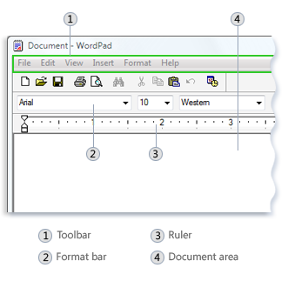
The WordPad window

There are four main parts of the WordPad window:
The toolbar
The toolbar contains buttons for basic commands, including saving and printing.
The format bar
The format bar contains buttons that you can use to format the text in your document. For example, you can choose the font, color, and alignment of your text.
The ruler
Use the ruler to check the plan and position of text in your document.
The document area
This is where you type your document, make changes to the text, and apply your formatting.

Typing text
A flashing vertical line called the cursor indicates where the next text that you type will appear in the document area.

Selecting text or highlighting a text
1. Position the mouse pointer to the left of where you want to begin your selection.
2. Click and hold the left mouse button while you drag (pull) the pointer over the text that you want to select.
Note: The selected text will be highlighted. Once you've completed your selection, release the mouse button.
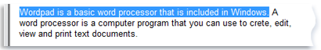

Copying a text

This means making a duplicate copy (second copy) in another place.

Steps
- Select the text to copy.
- Click Edit menu
- Click Copy.
- Move the cursor to the place where you want to insert (put) the copied text.
- Click Edit menu
- Click Paste.
Note
To quickly copy text that you've selected, press CTRL+C.
To paste it, press CTRL+V.

Moving a text to a different location
This means removing a text from its original place to another place.

Steps
- Select the text that you want to move.
- Click Edit menu
- Click Cut.
- Move the cursor to the place where you want to insert (put) the cut text.
- Click Edit menu
- Click Paste.

Inserting and deleting text

Insert means putting in or adding.

Deleting means removing.
To insert text
1. Click where you want to add the text
2. Start typing.
To delete text
1. Select the text that you want to delete or remove.
2. Press DELETE KEY on the keyboard.

Formatting a document
Formatting refers to changing the appearance of the document. For example, by changing to many different fonts and font sizes, color and underline.

To change the font, font style, or font size

Steps
- Select the text to change.
- Click Format menu.
- Click Font.
- In the Font window, select the font, size, colour or underline.
- Click OK
Here's a picture of a document with some different fonts and size applied:
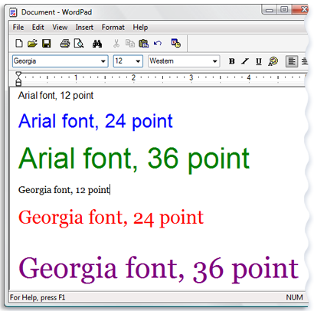

Saving your document
Saving means storing a document.

Steps
1. Click File menu
2. Click Save As.
3. In the Save in box, click the location where you want to save the document.
4. In the File name box, type a name for your document.
5. Click Save.

Printing your document
Printing means producing the typed work on a paper using a printer.
Steps
1. Click File menu
2. Click Print.
3. In the Print dialog box, use the Page Range box and the Number of copies box to specify which pages you want to print as well as how many copies.
4. Click Print.

Topical questions

1. What is WordPad?
WordPad is program you can use to create and edit documents.

2. What are the steps of opening WordPad?
a. Click Start button
b. Click All Programs / Programs
c. Click Accessories
d. Click WordPad.

3. How do I save a WordPad document for the first time?
- Click File menu
- Click Save As.
- In the Save in box, click the location where you want to save the document.
- In the File name box, type a name for your document.
- Click Save.

4. How do I print a WordPad document?

i. Click File menu
ii. Click Print.
iii. In the Print dialog box, use the Page Range box and the Number of copies box to specify which pages you want to print as well as how many copies.
iv. Click Print.

5. How do I insert the current a missed word into my document?
a. Click where you want to add the text.
b. Start typing.

6. How do I copy a text in WordPad?
- Select the text to copy.
- Click Edit menu
- Click Copy.
- Move the cursor to the place where you want to insert (put) the copied text.
- Click Edit menu
- Click Paste.

Bullets and Numbering
Steps
• Highlight the words you have typed.
• Choose Format from the menu bar.
• Choose Bullets and Numbering from the menu.
• Choose the Numbered tab.
• Several styles are available to you. Click the style you want to use.
• Click OK. Your list is now numbered.

